SilviShrooms: Predicting edible mushroom productivity using forest carbon allocation modeling and immunoassays of ectomycorrhizae.

D. Pilz¹, R. Molina¹, E. Danell², C. Rose³ and R.Waring³. ¹PNW Research Station, USDA Forest Service, Corvallis, OR. ²Swedish University of Agricultural Sciences, Uppsala, Sweden. ³Oregon State University, Corvallis, Oregon.

[Orally presented at the Second International Workshop on Edible Ectomycorrhizal Mushrooms. 3-6 July, 2001. Christchurch, New Zealand]

Abstract

Foresters could better evaluate habitat conditions for edible ectomycorrhizal mushroom production across a wide range of forest types if they had a mechanistic model that predicted how stand conditions and alternate silvicultural choices affect mushroom productivity. We hypothesize that the average potential of a site to produce the sporocarps of chanterelles and matsutake can be reasonably well predicted by (1) the food resources available to ectomycorrhizal fungi in a stand and (2) the occupancy of a site by these particular fungi (as measured by the percentage of ectomycorrhizal root tips they colonize).

A recently refined and widely applicable forest carbon allocation model allows prediction of how much net primary productivity in a forest stand is allocated to fine roots and mycorrhizae. The model will be modified to calculate the fraction of net primary productivity produced by ectomycorrhizal host tree species that are symbionts with chanterelles or matsutake. Immunoassay tests will provide quick and inexpensive evaluation of ectomycorrhizal root tips extracted from sample soil cores to determine the percentage colonized by the fungi of interest. Field trials will test the model’s predictions across a range of climate, stand age, and edaphic factors believed to influence the quantity of net primary productivity allocated below-ground.
Introduction

Edible mushrooms have been harvested from forests for as long as humans have foraged in woodlands, but in the later part of the 20th Century commerce in forest mushrooms became global, and annual international trade is now worth billions of US dollars. A large fraction of this trade is derived from the sporocarps (fruiting-bodies) of fungi that grow symbiotically with trees by forming ectomycorrhizae, a nutrient and water exchange structure consisting of fine tree roots and an enclosing sheath of fungal tissue. Ectomycorrhizal (EM) fungi act as an extended fine root system for trees and, in return, they obtain carbohydrates from host tree photosynthesis. These carbohydrates are one reason that EM fungi can fruit copiously each year if weather is favorable. Depending on the species, sporocarps of EM fungi can be mushrooms that fruit above ground or truffles that fruit below ground.

Well known edible EM fungi include chanterelles, matsutake, boletes, and truffles. Some edible EM fungi occur in the tropics and in inoculated plantations in the southern hemisphere, but most grow in temperate and boreal forests of the northern hemisphere with tree species in the Pinaceae and Fagaceae. Work is underway to cultivate edible EM fungi in plantations (Hall et al. 1998), but inoculation and establishment of most EM species has proven difficult (Danell 1994). Even if widely cultivated, forest mushrooms are likely to remain a viable commercial product for the foreseeable future.
The increase in harvesting of forest mushrooms and truffles has engendered concerns about whether the harvest is sustainable. Egli et al. (1990) and Norvell (1995) suggest that picking mushrooms per se has no discernable impact on subsequent fruiting in small areas over periods of a decade or two. Pilz and Molina (1998) have described a three-pronged regional research and monitoring program for tracking potential long-term or broad scale mushroom harvest impacts in the forests of the Pacific Northwest United States. To date, the monitoring program has not been implemented, but here we describe in greater detail our pursuit of the research component of this regional program.

Stand Conditions and Silvicultural Choices

Sustaining appropriate forest habitat is essential for sustaining associated EM mushroom crops. EM fungi exhibit varying degrees of specificity for arboreal host species, so tree species selection controls which fungi can occur in a stand. Clear-cutting a forest interrupts the fruiting of edible EM fungi for 1-3 decades as the new stand becomes established. Less well understood is how site conditions (soil fertility or climate), stand conditions (age, density, or growth rate) or management activities (commercial thinning or fertilization) affect mushroom productivity over time, and how mushroom values compare to timber or other resource values. Because many mushroom crops are harvested from the same forests that are managed for timber or other forest products and amenities, forest managers need a better understanding of how their choices will influence the size and value of mushroom crops if they are to optimally manage for multiple resource values.

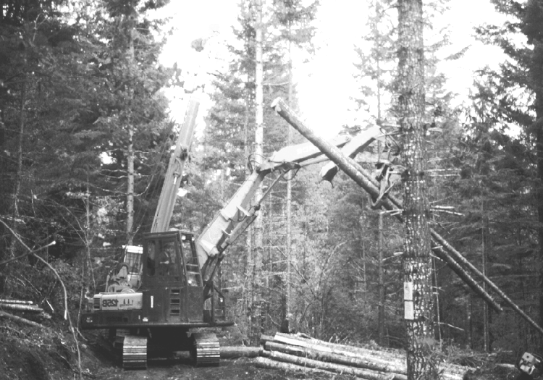

Young stand thinning operations in chanterelle habitat

Potential applications for predicting how environmental factors, stand conditions, and forest management choices influence the size and value of mushroom crops.

- Modify rotations, thinning densities, thinning intervals, or tree species selection to retain or enhance mushroom productivity in forests predominantly managed for timber production.
- Manage stands in areas with convenient access for mushroom picking to enhance long-term mushroom production.
- Lengthen rotations or refrain from harvesting timber in areas identified as having low timber value and high mushroom productivity.
- Manage stand conditions to promote mushroom production in forests not intended for timber production (for example, carbon sequestration).
- Provide continuous mushroom harvesting opportunities across watersheds, land ownerships, or bioregions as the mosaic of forest conditions and age classes shifts across the landscape.
- Maintain mushroom harvesting opportunities in the coming centuries by anticipating the shifts in forest biomes as they respond to global warming or other anthropogenic factors.

Investigative Approaches

Biological, ecological, and physiological research have provided hypotheses for the influence of factors affecting mushroom productivity, but testing hypotheses with replicated experiments on a stand or at landscape scales is very expensive and inferences derived from the results are limited to the stand conditions and forest types where the experiments were conducted. For instance, the Young Stand Thinning and Diversity Study (http://www.fsl.orst.edu/mycology/youngstndthin/Yss.html)
on the Willamette National Forest in Oregon is an example of a landscape level silvicultural experiment, but chanterelle productivity is only one of many dependent variables. A much more cost-effective and broadly applicable approach will be development of a quantitative ecosystem process model that predicts mushroom productivity over a broad range of forest types, stand conditions, and site factors. Fortuitously, we believe that a confluence of scientific advances has made development of such a model possible.

Our Central Hypothesis:

Average site productivity of selected edible EM mushroom species can be usefully predicted by:

1. the amount of net primary productivity (NPP) allocated below-ground by EM trees in a stand and,
2. the site occupancy of that stand by the fungus of interest.

The 3PG Model

3PG is an acronym for Physiological Principles Predicting Growth. It is a generalized forest carbon allocation model, published by Landsberg and Waring (1997), that works with any forest biome and can be run as an Excel spreadsheet by practicing foresters given a few days of training. The model uses relatively simple and readily available inputs such as species growth tables, latitude, aspect, weather records, edaphic variables, stand age, and stand density to derive monthly estimates of gross primary productivity, carbon allocation, and stand growth. The model has the capacity for specifying thinning regimes, although the function needs further refinement. In recent iterations, the 3PG model has been linked to satellite imagery of canopy photosynthetic capacity to model forest growth across landscapes (Coops et al. 1998). Intended as a practical management tool, the model is under constant revision to incorporate new research data, simplify application, and broaden its usefulness. Belowground processes and allocation are one of the least developed aspects of this model and we hope to contribute to the model's development with our envisioned research and application.

Flowchart for 3PG Model
http://www.ffp.csiro.au/nfm/mdp/bevr/model.html

Definitions for mushroom productivity modeling

Fruiting Potential

The maximum productivity that is possible on a given site in a given year if weather is favorable for mushroom development during the fruiting season.

Average Site Productivity

The average mushroom productivity of a site over 4-10 years, measured in kg/ha/yr or equivalent units. This variable provides a mean of expressed fruiting potential by averaging across multiple years of annual variation in weather patterns during the fruiting seasons. Conversely, 4-10 years is a sufficiently short interval that natural changes in stand conditions should not unduly interfere with deriving correlations for our model.

Site Occupancy

The percentage of potential habitat that is occupied by the edible EM fungal species of interest relative to competing EM fungi as measured by the percentage of EM root tips colonized by the species of interest or by the spatial extent of its mycelium.

Gross Primary Productivity (GPP)

Total quantity of carbon fixed through photosynthesis in the form of carbohydrates or other metabolic compounds.

Net Primary Productivity (NPP)

Net quantity of carbon available to the tree or its mycorrhizal fungus partners for growth or other functions after subtracting the amount used for tree respiration (maintenance metabolism). Net primary productivity is a relatively constant 47%, of gross primary productivity across a wide range of forest types and conditions.

Belowground allocation

The proportion or amount of net primary productivity that the tree allocates for large structural roots, fine feeder roots, and mycorrhizal symbionts.

Carbon Allocation

A variety of factors are known to influence the allocation of carbon below ground. For instance, trees are known to allocate a larger proportion of their NPP below ground on infertile sites than on fertile sites. Much of this allocation goes to mycorrhizal fungi to enhance their ability to obtain nutrients. The same is true of old forests, and of boreal or high elevation forests growing on cold soils, where nutrients are often tightly bound in accumulated organic matter. Taller trees are more prone to drought-related stress than shorter trees because they experience greater hydraulic resistance moving water to a more distant canopy, hence, they allocate a greater proportion of NPP below ground to obtain water in dry seasons (a process also facilitated by mycorrhizal fungi).
Most factors that limit tree growth also increase the proportion of NPP allocated below ground. It is possible that mushroom productivity will be significantly correlated with a simple integrative measure of growth constraints such as site index (the ratio of tree height to age), and we will test this possibility. Our hypothesis states, however, that mushroom productivity is correlated with the amount (kg/ha/yr) of NPP allocated below ground, not the proportion. Because NPP is a relatively constant fraction of GPP (see definitions) the quantity of NPP allocated belowground is a function of gross primary productivity as well as proportional allocation of NPP. In other words, although growth constraints cause trees to allocate a greater proportion of their food resources belowground, they have less available food to begin with because they are growing more slowly.

One of the more important questions we hope to address with our research is how the quantity of food available to mycorrhizal fungi varies across gradients of site fertility, soil temperatures, and stand age.

The Cryptic Realm

Of the NPP allocated belowground, the proportion allocated to large structural roots is about 25% of the NPP allocated to stem wood. The remainder is available for fine roots and mycorrhizae. Although carbon allocation patterns are relatively well known for most structural and functional components of tree growth and metabolism, the allocation and use of NPP among fine roots and mycorrhizae is not yet well quantified. Likewise we have little information about how EM fungi compete for arboreal carbohydrates or how various species of EM fungi allocate acquired carbon to growth, metabolism, function, or the production of sporocarps. Because so little quantitative information exists about carbon allocation in this realm, we start with two simplifying assumptions: (1) the amount of carbon each EM species obtains from trees in the stand will be correlated with site occupancy of that EM species, and (2) site occupancy will be correlated with average site productivity for each EM species. Although we expect these correlations to be robust, we also expect parameter values for the correlations to vary between fungus species.

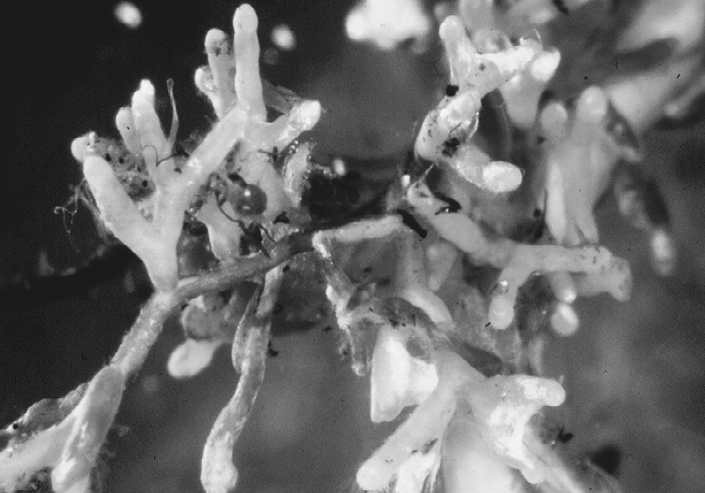

Chanterelle mycorrhizae. Photo by Eric Danell.

Estimating Site Occupancy

Immunoassays of ectomycorrhizae

In collaboration with Dr. Eric Danell, we anticipate contracting with immunoassay development companies to develop monoclonal antibody reagents (Miller et al. 1998, Neuner-Plattner et al. 1999) that will allow us to quickly assay the percentage of ectomycorrhizae in stands colonized by either chanterelles or matsutake.

Olfactory surveys of matsutake mats

Chanterelle mycelia grow diffusely in the soil so directly estimating their mass or volume is not currently feasible. Matsutake mycelia, however, grow in dense mats near the surface of the mineral soil and the mats exude the distinctive odor of matsutake. Charles LeFevre, as a part of his graduate thesis, has developed, tested, and refined olfactory sampling procedures for estimating the areal extent of matsutake mycelia in a forest stand.



Testing olfactory methods for detecting Tricholoma magnivelare mycelium in soil.

Percentage occurrence in productivity plots

As a backup to both of these approaches to estimating site occupancy, we plan to sample mushroom productivity using numerous systematically located small plots. The percentage of plots that are occupied by either chanterelles or matsutake will give us a less direct, but hopefully still useful, estimate of the site occupancy for each species.

Mushroom species to be modeled

Chanterelles and matsutake were chosen for this project because they are among the most widely collected and traded species in international commerce, and both are widely distributed in temperate and boreal forests of the northern hemisphere (Bergius and Danell 2000, Danell 1999). They occur in sufficient abundance to facilitate site selection and reliably sample. We have used these species for comparative evaluations of mushroom and timber values, so economic analyses can be readily extrapolated to mushroom and timber productivity estimates derived from our model. Immunoassays will be designed for specificity to the genus Cantharellus, and for matsutake we will plan reagents specific to the unique odor molecule produced by the several species of Tricholoma that are harvested as "matsutake" around the world.

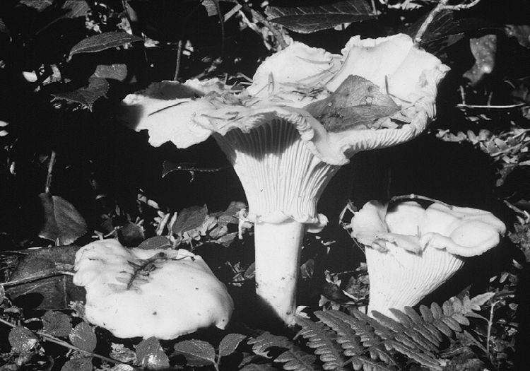

Chanterelles (Cantharellus subalbidus).

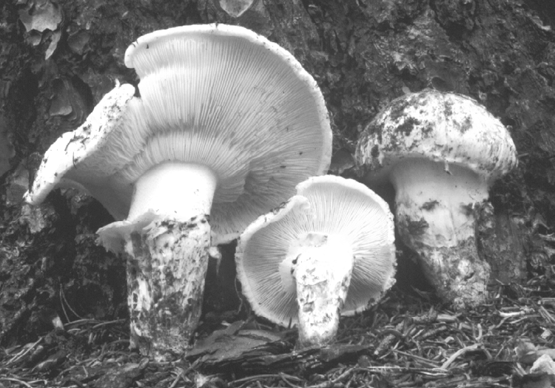

American matsutake (Tricholoma magnivelare).

Selection of field sites

We plan to select field sites that cover the range of climatic and edaphic conditions that we hypothesize are important to mushroom productivity. Factors driving site selection will include sufficient fruiting of chanterelles or matsutake, high versus low soil fertility, temperate versus boreal climates, and old versus young forests. The correlations we develop and the predictions of our resulting model will be tested on other sites where long-term mushroom productivity estimates already exist, such as the Young Stand Thinning and Diversity Study.

The larger picture

Immunoassays

Successful development of immunoassay reagents for chanterelles and matsutake will provide useful tools to sample stands for potential mushroom productivity even when the mushrooms are not fruiting. They can also be used to verify fungal persistence in plantations of trees inoculated with these species.

Economic valuation

Timber values are thoroughly understood, but mushroom values are harder to estimate and most attempts are relatively recent (Pilz et al. 1998, Pilz et al 1999, and Alexander et al. submitted). These preliminary analyses include many economic assumptions about mushroom prices and harvester costs, but they also include uncertain assumptions about how timber management choices affect mushroom productivity. Coupling analyses of mushroom values with predictions of mushroom productivity under varied forest management scenarios will allow managers to better evaluate resource tradeoffs and synergies.

Seasonal variations in carbon allocation

Our core modeling efforts will not provide estimates of the fruiting potential of a stand in any given year, only multi-year averages. Physiological evidence exists, however, that seasonal weather patterns likely influence the amount of carbon allocated belowground immediately prior to and during the mushroom fruiting season. If the affects of weather patterns on seasonal carbon allocation are further elucidated, the information might provide a means for predicting fruiting potential in a given year, so we also plan to test this hypothesis by developing actual carbon allocation budgets for the stands we sample.

Scaling from stands to landscapes

Evaluating commercial mushroom crops and their values at the scale of landscapes would enable planners or policy analysts to anticipate how regional mushroom crops might be influenced by changes in climate, pollution, exotic forest pests, forest age class distributions, timber management regimes, or land-use patterns. Satellite sensing of canopy conditions for scaling the 3PG model to landscape estimates of mushroom productivity will be ineffective, however, unless we better understand the range and habitat preferences of the modeled mushroom species. After the core modeling research is underway, we plan to survey mushroom experts (mycology club members, agency botanists, and commercial mushroom harvesters) about the habitat preferences of commercially harvested mushroom species. By incorporating summaries of this habitat information into geographic information system (GIS) databases, we will be able to select appropriate habitat strata for application of remotely sensed canopy data. This approach will allow us to more accurately calculate mushroom productivity and crop values at watershed, landscape, or regional scales.

Cooperators

Corresponding Author: David Pilz, Botanist, Forest Mycology Team
Pacific Northwest (PNW) Research Station
US Department of Agriculture, Forest Service
Forestry Sciences Laboratory
3200 SW Jefferson Way, Corvallis, Oregon 97331
(541) 753-6209, dpilz@fs.fed.us

- Randy Molina, PNW Research Station, USDA Forest Service, Corvallis, OR
- Eric Danell, Dept. of Forest Mycology and Pathology, Swedish University of Agricultural Sciences (SLU), Uppsala, Sweden
- Richard Waring, Department of Forest Science, Oregon State University, Corvallis, OR
- Catherine Rose, Department of Forest Science, Oregon State University, Corvallis, OR
- Susan Alexander, Social and Economic Values Program, PNW Research Station, USDA Forest Service, Corvallis, OR
- Mark Savage, Forest Resources, Washington State Department of Natural Resources, Olympia, WA
- Kermit Cromack, Department of Forest Science, Oregon State University, Corvallis, OR
- Daniel Luoma, Department of Forest Science, Oregon State University, Corvallis, OR
- Charles LeFevre, Department of Forest Science, Oregon State University, Corvallis, OR

References

Alexander, S. J., Pilz, D., Weber, N. S., Brown, E. and Rockwell, V. [Submitted] Value estimates of commercial mushrooms and timber in the Pacific Northwest. Environmental Management.
Bergius, N., and Danell, E. 2000. The Swedish matsutake (Tricholoma nauseosum syn. T. matsutake): distribution, abundance, and ecology. Scandinavian Journal of Forest Research 15: 318-325.
Coops, N. C., Waring, R. H., and Landsberg, J. J. 1998. Assessing forest productivity in Australia and New Zealand using a physiologically-based model driven with averaged monthly weather data and satellite derived estimates of canopy photosynthetic capacity. Forest Ecology and Management 104: 113-127.
Danell, E. 1994. Formation and growth of the ectomycorrhiza of Cantharellus cibarius. Mycorrhiza. 5: 89-97.
Danell, E. 1999. Cantharellus. Chapter 10. In: Cairney, J. W. G. and Chambers, S. M. eds. Ectomycorrhizal fungi: key genera in profile. Springer-Verlag. Berlin.
Egli, S., Ayer, F., Chatelain, F. 1990. Der Einfluss des Pilzsammelns auf die Pilzflora. Mycologia Helvetica 3: 417-428.
Hall, I., Buchanan, P. K., Yun, W., and Cole, A. L. J. 1998. Edible and poisonous mushrooms: an introduction. New Zealand Institute for Crop & Food Research Limited. Christchurch, NZ.
Landsberg, J. J. and Waring, R. H. 1997. A generalized model of forest productivity using simplified concepts of radiation use efficiency, carbon balance and partitioning. Forest Ecology and Management 95: 209-228.
Miller, S. A., Rittenburg, J. H., Peterson, F. P. and Grothaus, G. D. 1988. Application of rapid, field usable immunoassays for the diagnosis and monitoring of fungal pathogens in plants. pp. 795-803. In: Brighton Crop Protection Conference, Pests and Diseases. Surrey: British Crop Protection Council.
Norvell, L. 1995. Loving the chanterelle to death? The ten-year Oregon chanterelle project. McIlvainea 12: 6-25.
Neuner-Plattner, I., Grabher, T., Hall, I. R., Stöffler, G., Griffin, F. and Haselwanter, K. 1999. A comparison of immunological assays for the identification of Tuber spp. and other edible EM fungi. Mycological Research 103(4): 403-412.
Pilz, D., Molina, R., 1998. A proposal for regional monitoring of edible forest mushrooms. Mushroom, The Journal of Wild Mushrooming. 16(3): 19-23.
Pilz, D., Brodie, F. D., Alexander, S., and Molina, R. 1998. Relative value of chanterelles and timber as commercial forest products. pp. 14-15. In: Liegel, L. H. (compiler). The biological, socioeconomic, and managerial aspects of chanterelle mushroom harvesting: The Olympic Peninsula, Washington State, U.S.A. Ambio, A Journal of the Human Environment. Special Report Number 9, September, 1998. Stockholm, Sweden: Royal Swedish Academy of Sciences.
Pilz, D., Smith, J., Amaranthus, M. P., Alexander, S., Molina, R. and Luoma, D. 1999. Mushrooms and timber: managing commercial harvesting in the Oregon Cascades. Journal of Forestry 97(3): 4-11.

